**Week -1 Design Principles and Patterns Mandatory HandsOn Solutions**

**Exercise 1: Implementing the Singleton Pattern**

**Source code**:

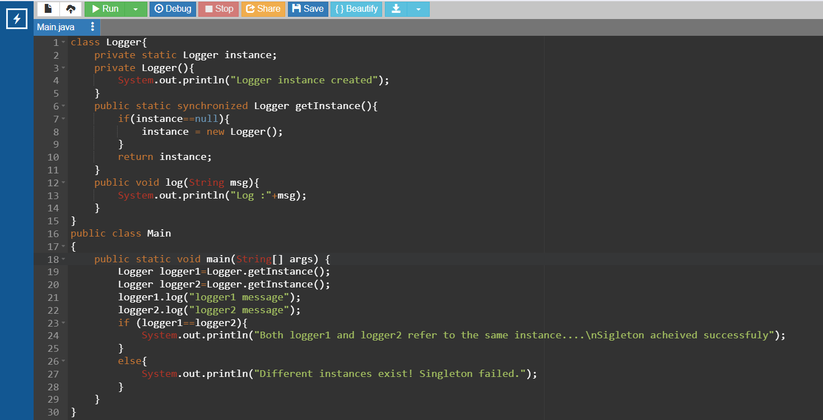

**Output:**

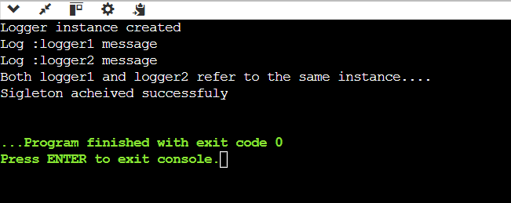

**Design Principles and Patterns**

**Exercise 2: Implementing the Factory Method Pattern**

**Source code:**

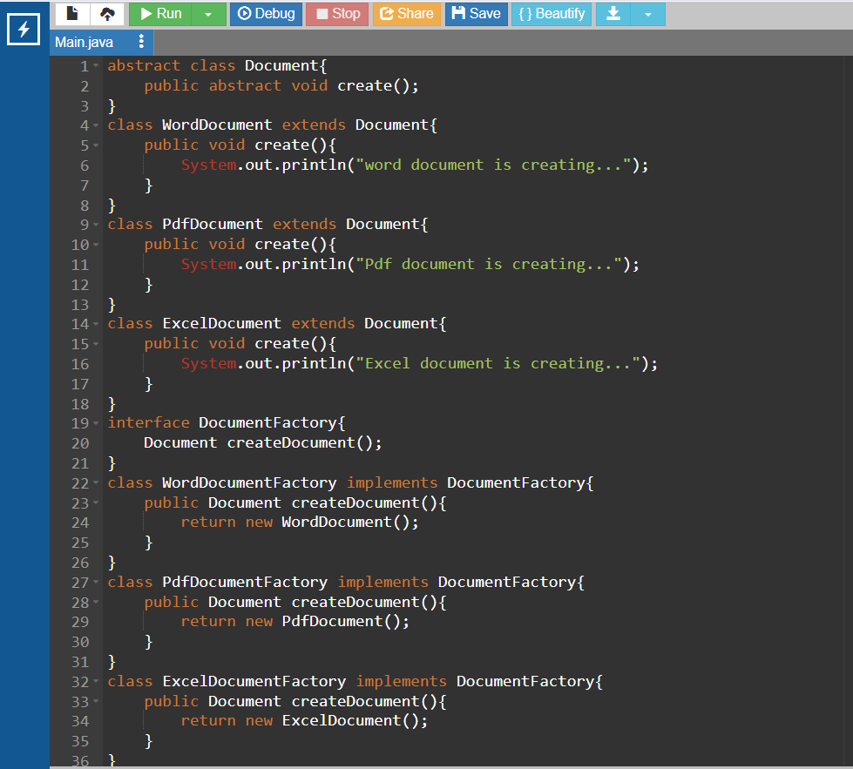

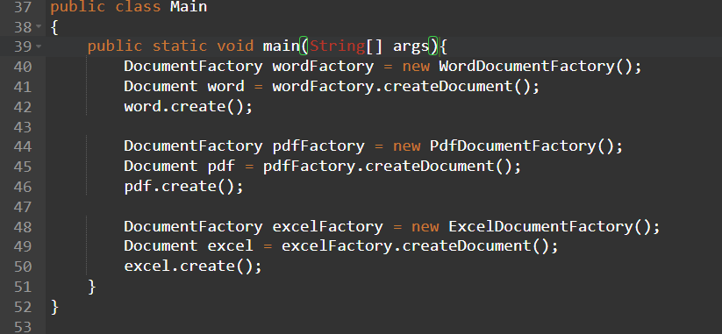

**Output:**

